Array

What is an Array?
# Source: AI Source: Provided by: [Data Path: Persons Table -> ID Column: 1, Name_En Column: Motasem Essam] -> From: [Chatgpt (GPT‑5 Mini)] on [12/10/2025]
An Array is a data structure that stores multiple values of the same data type in a single variable.
The values are stored in contiguous memory locations and accessed using an index (position number).

Key Characteristics
# Source: AI Source: Provided by: [Data Path: Persons Table -> ID Column: 1, Name_En Column: Motasem Essam] -> From: [Chatgpt (GPT‑5 Mini)] on [12/10/2025]
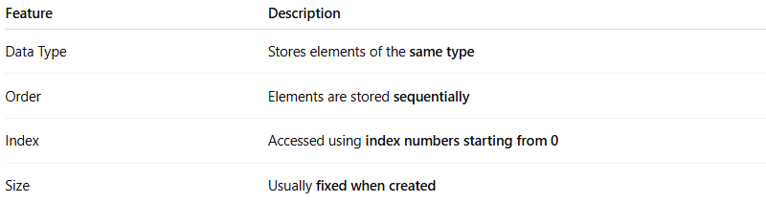
Feature | Description
Data Type | Stores elements of the same type
Order | Elements are stored sequentially
Index | Accessed using index numbers starting from 0
Size | Usually fixed when created

Types of Arrays
# Source: AI Source: Provided by: [Data Path: Persons Table -> ID Column: 1, Name_En Column: Motasem Essam] -> From: [Chatgpt (GPT‑5 Mini)] on [12/10/2025]
- One-Dimensional Array (1D Array)
  - Stores elements in a single row.
  - Accessed using one index.
  - Example:
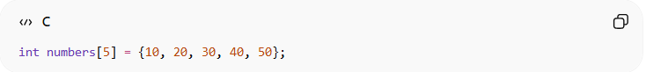
int numbers[5] = {10, 20, 30, 40, 50};
- Two-Dimensional Array (2D Array)
  - Stores elements in a table format (rows and columns).
  - Accessed using two indices [row][column].
  - Example:
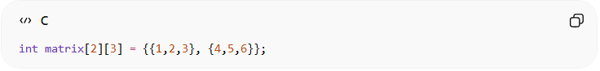
int matrix[2][3] = {{1,2,3}, {4,5,6}};
- Multi-Dimensional Array
  - Stores elements in more than 2 dimensions.
  - Accessed using multiple indices.
  - Example:
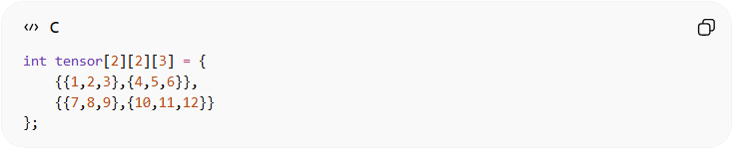
int tensor[2][2][3] = {
{{1,2,3},{4,5,6}},
{{7,8,9},{10,11,12}}
};
- Static Array (Fixed Size)
  - Size is defined at compile-time and cannot change.
  - Stored in contiguous memory.
  - Example:
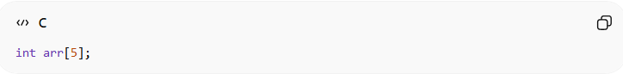
int arr[5];
- Dynamic Array (Resizable)
  - Size can grow or shrink at runtime.
  - Often implemented using pointers or built-in classes like ArrayList in Java or vector in C++.
  - Example in C++:
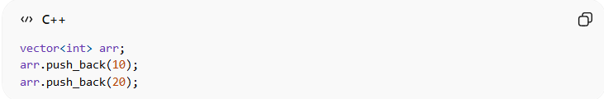
vector<int> arr;
arr.push_back(10);
arr.push_back(20);
- Character Array
  - Stores characters, often used to store strings.
  - Example:
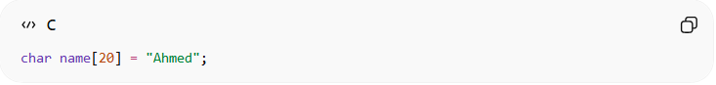
char name[20] = "Ahmed";
- Jagged Array (Array of Arrays)
  - Each row can have different number of columns.
  - Mostly used in languages like C# or Java.
  - Example in C#:
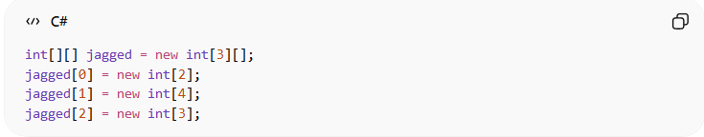
int[][] jagged = new int[3][];
jagged[0] = new int[2];
jagged[1] = new int[4];
jagged[2] = new int[3];
- Boolean Array
  - Stores true/false values.
  - Example:
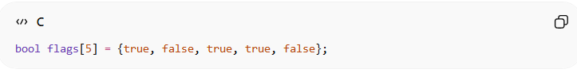
bool flags[5] = {true, false, true, true, false};

Summary Table of Array Types
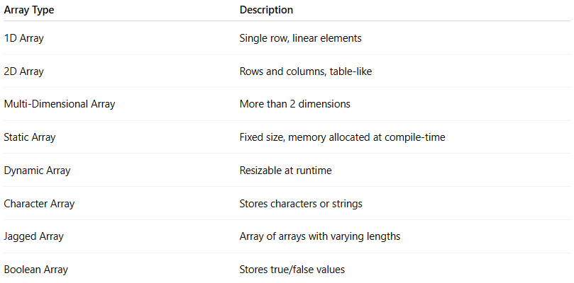
Array Type | Description
1D Array | Single row, linear elements
2D Array | Rows and columns, table-like
Multi-Dimensional Array | More than 2 dimensions
Static Array | Fixed size, memory allocated at compile-time
Dynamic Array | Resizable at runtime
Character Array | Stores characters or strings
Jagged Array | Array of arrays with varying lengths
Boolean Array | Stores true/false values

Example of an Array
# Source: AI Source: Provided by: [Data Path: Persons Table -> ID Column: 1, Name_En Column: Motasem Essam] -> From: [Chatgpt (GPT‑5 Mini)] on [12/10/2025]
[10, 20, 30, 40, 50]
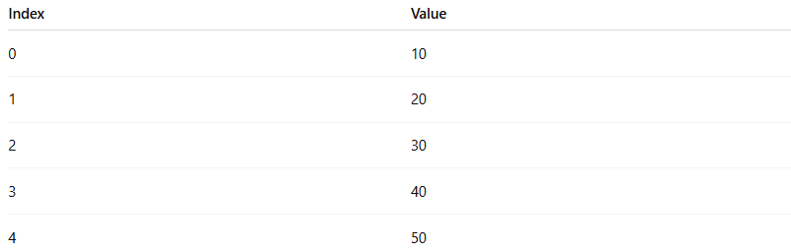
Index | Value
0 | 10
1 | 20
2 | 30
3 | 40
4 | 50

Example in Programming

C / C++
# Source: AI Source: Provided by: [Data Path: Persons Table -> ID Column: 1, Name_En Column: Motasem Essam] -> From: [Chatgpt (GPT‑5 Mini)] on [12/10/2025]
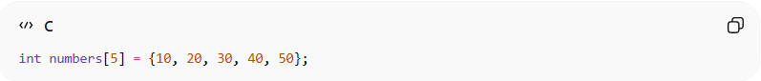
int numbers[5] = {10, 20, 30, 40, 50};
Accessing an element:
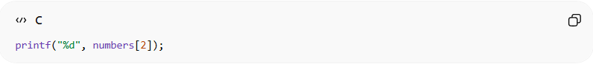
printf("%d", numbers[2]);
Result:
30

Common Operations on Arrays

1. Access (Reading an Element)
# Source: AI Source: Provided by: [Data Path: Persons Table -> ID Column: 1, Name_En Column: Motasem Essam] -> From: [Chatgpt (GPT‑5 Mini)] on [12/10/2025]
Definitions:
Accessing means retrieving a specific element from the array using its index.

An index is the position number of an element inside the array.
It tells the program where the element is located.
Most programming languages start indexing from 0, not 1.

Arrays use index numbers starting from 0.
Example Array:
[10, 20, 30, 40, 50]
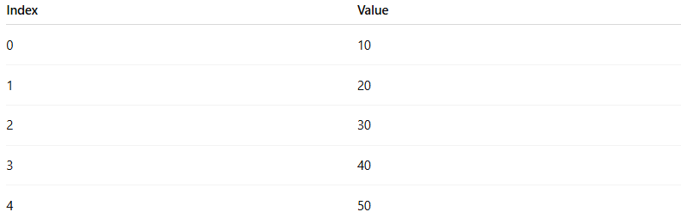
Index | Value
0 | 10
1 | 20
2 | 30
3 | 40
4 | 50
If we access index 2, we get 30.

So the index acts like the address or position of the element in the array.
Why Index Starts at 0:
Arrays start at 0 because the index represents the distance from the first memory location of the array.
Example conceptually:
Array start address + index = element location
So:
arr[0] → first element
arr[1] → second element
arr[2] → third element
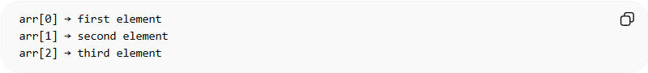
Example in C:
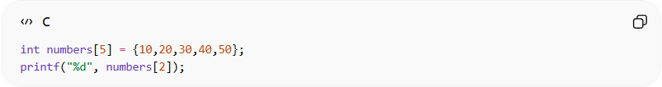
int numbers[5] = {10,20,30,40,50};
printf("%d", numbers[2]);
Output
30
Access Time Complexity:
- Time Complexity: O(1)
- Reason: The position of the element is known, so the program can directly reach the memory location using the index.

2. Insertion (Adding an Element)
# Source: AI Source: Provided by: [Data Path: Persons Table -> ID Column: 1, Name_En Column: Motasem Essam] -> From: [Chatgpt (GPT‑5 Mini)] on [12/10/2025]
Definition:
Insertion means adding a new element into the array.
Sometimes elements must be shifted to the right to create space.
Example:
Original array:
[10, 20, 30, 40]
Insert 25 at index 2
Step 1 – shift elements
[10, 20, _, 30, 40]
Step 2 – insert value
[10, 20, 25, 30, 40]
Example in C:
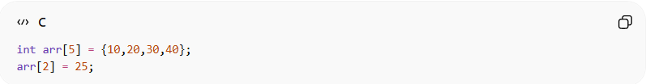
int arr[5] = {10,20,30,40};
arr[2] = 25;
Insertion Time Complexity:
- Time Complexity: O(n)
- Reason: Elements after the insertion position may need to shift to the right to create space for the new element.

3. Deletion (Removing an Element)
# Source: AI Source: Provided by: [Data Path: Persons Table -> ID Column: 1, Name_En Column: Motasem Essam] -> From: [Chatgpt (GPT‑5 Mini)] on [12/10/2025]
Definition:
Deletion removes an element from the array.
After removing the element, other elements usually shift left to fill the empty space.
Example:
Original array
[10, 20, 30, 40, 50]
Delete element 30
Step 1 – remove
[10, 20, _, 40, 50]
Step 2 – shift elements left
[10, 20, 40, 50]
Example in C:
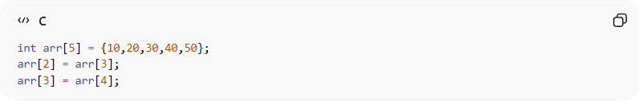
int arr[5] = {10,20,30,40,50};
arr[2] = arr[3];
arr[3] = arr[4];
Deletion Time Complexity:
- Time Complexity: O(n)
- Reason: Elements after the deleted element must shift left to fill the empty space.

4. Traversal (Visiting All Elements)
# Source: AI Source: Provided by: [Data Path: Persons Table -> ID Column: 1, Name_En Column: Motasem Essam] -> From: [Chatgpt (GPT‑5 Mini)] on [12/10/2025]
Definition:
Traversal means going through every element in the array one by one.
It is often used to:
- Print values
- Calculate totals
- Modify elements
Example Array:
[5, 10, 15, 20]
Traversal prints:
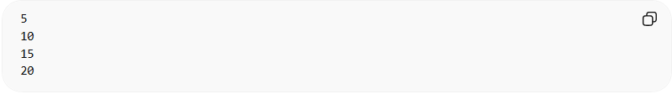
5
10
15
20
Example in C:
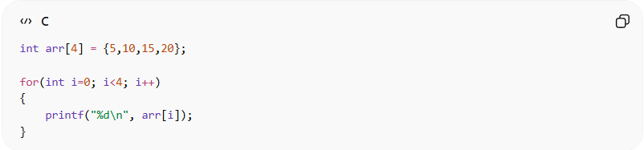
int arr[4] = {5,10,15,20};

for(int i=0; i<4; i++)
{
printf("%d\n", arr[i]);
}
Traversal Time Complexity:
- Time Complexity: O(n)
- Reason: The program must visit every element in the array one by one

5. Searching (Finding an Element)
# Source: AI Source: Provided by: [Data Path: Persons Table -> ID Column: 1, Name_En Column: Motasem Essam] -> From: [Chatgpt (GPT‑5 Mini)] on [12/10/2025]
Definition:
Searching means finding the position of a specific value in the array.
Example
Array:
[10, 20, 30, 40, 50]
Search for 30
Result:
Index = 2
Example in C (Linear Search):
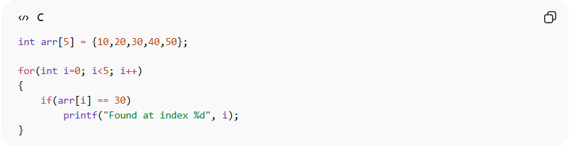
int arr[5] = {10,20,30,40,50};

for(int i=0; i<5; i++)
{
if(arr[i] == 30)
printf("Found at index %d", i);
}
Searching Time Complexity:
- Time Complexity: O(n)
- Reason: In an unsorted array, the program may need to check each element until the target value is found.

Summary of Array Operations
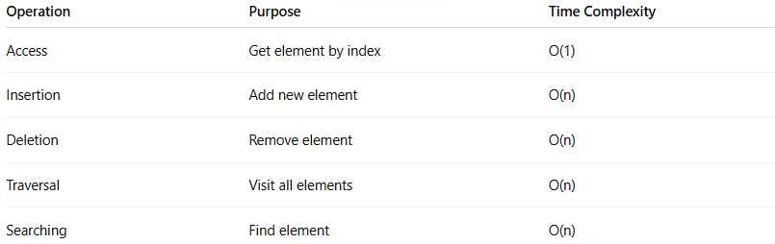
Operation | Purpose | Time Complexity
Access | Get element by index | O(1)
Insertion | Add new element | O(n)
Deletion | Remove element | O(n)
Traversal | Visit all elements | O(n)
Searching | Find element | O(n)

Real-World Examples
# Source: AI Source: Provided by: [Data Path: Persons Table -> ID Column: 1, Name_En Column: Motasem Essam] -> From: [Chatgpt (GPT‑5 Mini)] on [12/10/2025]
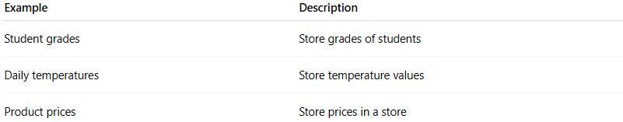
Example | Description
Student grades | Store grades of students
Daily temperatures | Store temperature values
Product prices | Store prices in a store

Advantages of Arrays
# Source: AI Source: Provided by: [Data Path: Persons Table -> ID Column: 1, Name_En Column: Motasem Essam] -> From: [Chatgpt (GPT‑5 Mini)] on [12/10/2025]
- Fast access using index
- Simple to use
- Efficient memory usage

Disadvantages of Arrays
# Source: AI Source: Provided by: [Data Path: Persons Table -> ID Column: 1, Name_En Column: Motasem Essam] -> From: [Chatgpt (GPT‑5 Mini)] on [12/10/2025]
- Fixed size (in many languages)
- Insertion and deletion can be slow
- Can only store one data type

